**1. In what modes should the PdfFileReader() and PdfFileWriter() File objects will be opened?**

**Ans:** For **PdfFileReader()** file objects WILL be opened in **rb** -> read binary mode, Whereas for **PdfFileWriter()** file objects WILL be opened in **wb** -> write binary mode.

**2. From a PdfFileReader object, how do you get a Page object for page 5?**

**Ans: PdfFileReader** class provides a method called **getPage(page_no)** to get a page object.

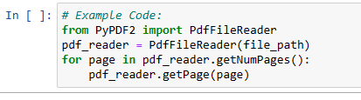

**3. What PdfFileReader variable stores the number of pages in the PDF document?**

**Ans:**  **getNumPages()** method of **PdfFileReader** class stores the no pages in a PDF document

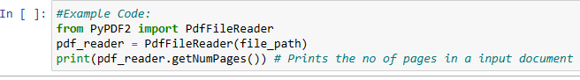

**4. If a PdfFileReader object’s PDF is encrypted with the password swordfish, what must you do before you can obtain Page objects from it?**

**Ans:**  If a **PdfFileReader** object’s PDF is encrypted with the password **swordfish** and we are not aware of it, we will first read the Pdf using the PdfFileReader Class. PdfFileReader class provides a attribute called **isEncrypted** to check whether a pdf is encrypted or not. The method returns true if a pdf is encrypted and vice versa.  
If pdf is encrypted we will use the **decrypt()** method provided by PdfFileReader class and then we will try to read the contents/pages of the pdf, else PyPDF2 will raise the following error **PyPDF2.utils.PdfReadError: file has not been decrypted**

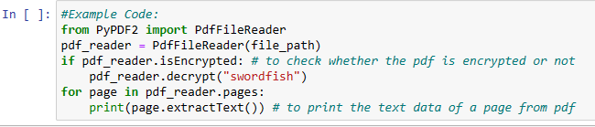

**5. What methods do you use to rotate a page?**

**Ans:** PyPDF2 Package provides 2 methods to rotate a page:

1. **rotateClockWise()** -> For Clockwise rotation
2. **rotateCounterClockWise()** -> For Counter Clockwise rotation

**6. What is the difference between a Run object and a Paragraph object?**

**Ans:** The structure of a document is represented by three different data types in **python-Docx**. At the highest level, a Document object represents the entire document. The Document object contains a list of **Paragraph** objects for the paragraphs in the document. (A new paragraph begins whenever the user presses ENTER or RETURN while typing in a Word document.) Each of these Paragraph objects contains a list of one or more **Run** objects.

The text in a Word document is more than just a string. It has font, size, color, and other styling information associated with it. A style in Word is a collection of these attributes. A Run object is a contiguous run of text with the same style. A new Run object is needed whenever the text style changes.

**8. What type of object has bold, underline, italic, strike, and outline variables?**

**Ans: Run** object has bold, underline, italic, strike, and outline variables. The text in a Word document is more than just a string. It has font, size, color, and other styling information associated with it.

A style in Word is a collection of these attributes. A Run object is a contiguous run of text with the same style. A new Run object is needed whenever the text style changes.

**9. What is the difference between False, True, and None for the bold variable?**

**Ans:**

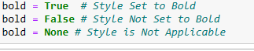

**10. How do you create a Document object for a new Word document?**

**Ans:**

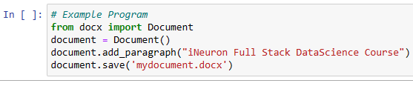

**11. How do you add a paragraph with the text 'Hello, there!' to a Document object stored in a variable named doc?**

**Ans:**

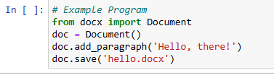

**12. What integers represent the levels of headings available in Word documents?**

Ans: The levels for a heading in a word document can be specified by using the **level** attribute inside the **add_heading** method. There are a total of 5 levels statring for 0 to 4. where level 0 makes a headline with the horizontal line below the text, whereas the heading level 1 is the main heading. Similarly, the other headings are sub-heading with their's font-sizes in decreasing order.